Task on VPC Transit Gateway & VPC Endpoint

1) Create one VPC, with 1 public subnet and 1 private subnet.
Step 1: Create a VPC
- Login to AWS Console.
- Go to VPC.
- Click Create VPC.
- Select VPC only.
- Enter:
  - Name: My-VPC
  - IPv4 CIDR: 10.0.0.0/16
- Click Create VPC.
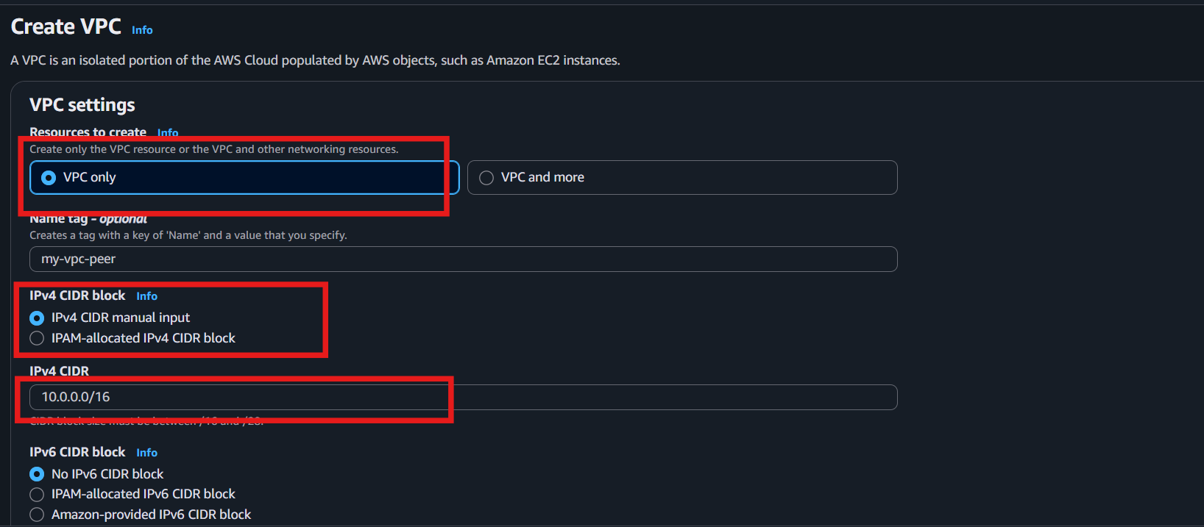

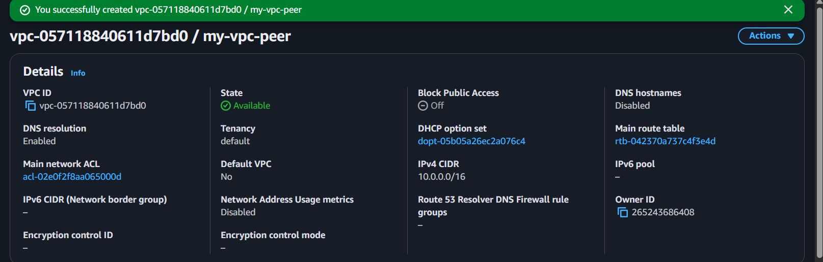

Step 2: Create a Public Subnet
- In the left menu, click Subnets.
- Click Create subnet.
- Select My-VPC.
- Enter:
  - Subnet name: Public-Subnet
  - Availability Zone: Choose any (e.g., us-east-1a)
  - IPv4 CIDR: 10.0.1.0/24
- Click Create subnet.
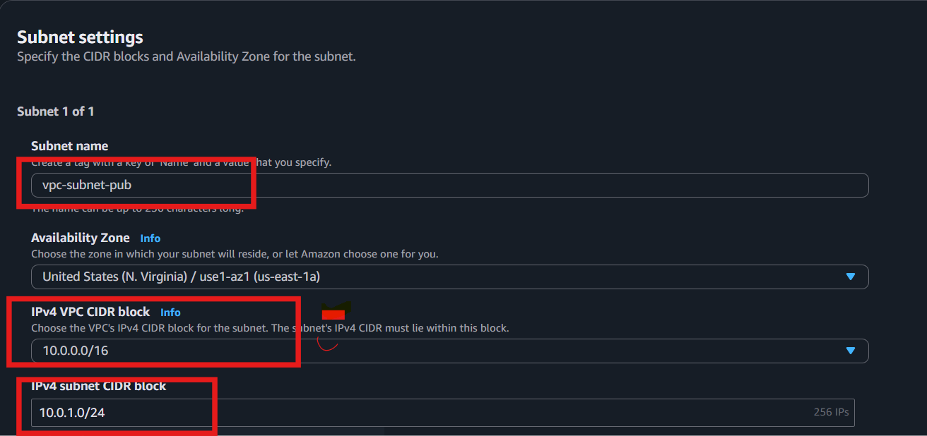
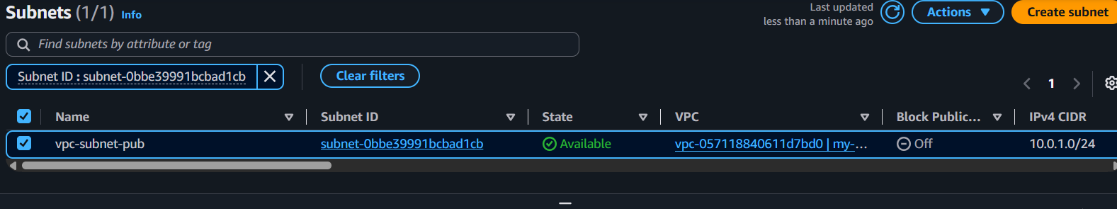

Step 3: Create a Private Subnet
- Click Create subnet again.
- Select My-VPC.
- Enter:
  - Subnet name: Private-Subnet
  - Availability Zone: Same or another AZ
  - IPv4 CIDR: 10.0.2.0/24
- Click Create subnet.
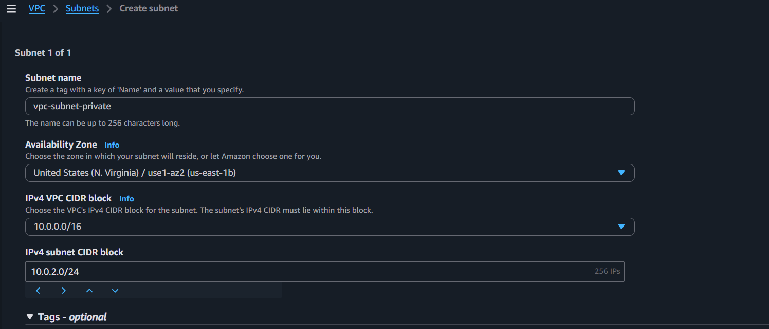
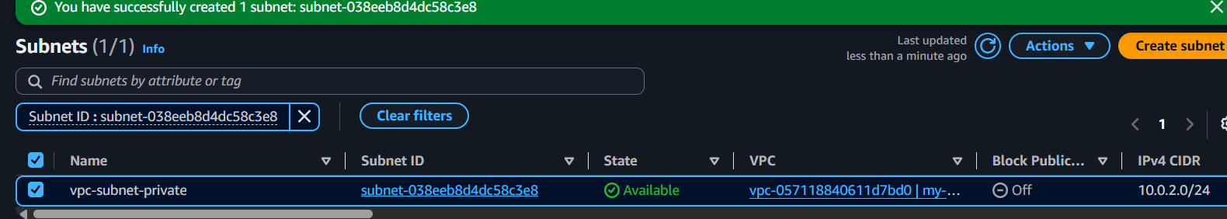

Step 4: Enable Auto-Assign Public IP (Public Subnet Only)
- Go to Subnets.
- Select Public-Subnet.
- Click Actions → Edit subnet settings.
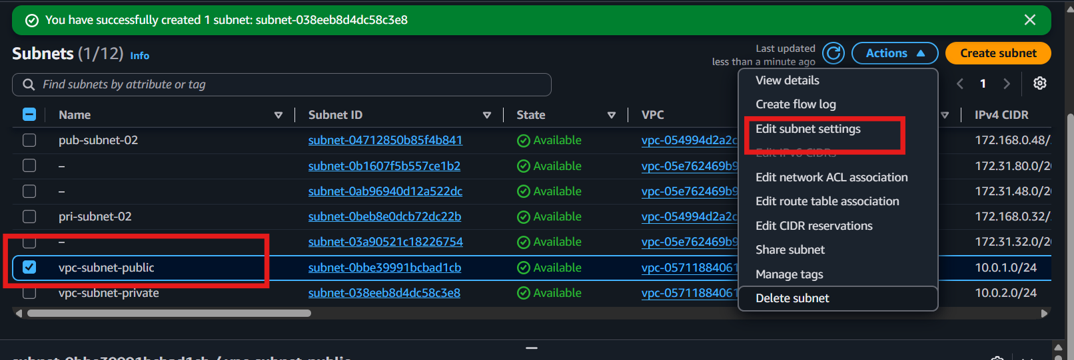
- Check Enable auto-assign public IPv4 address.
- Click Save.
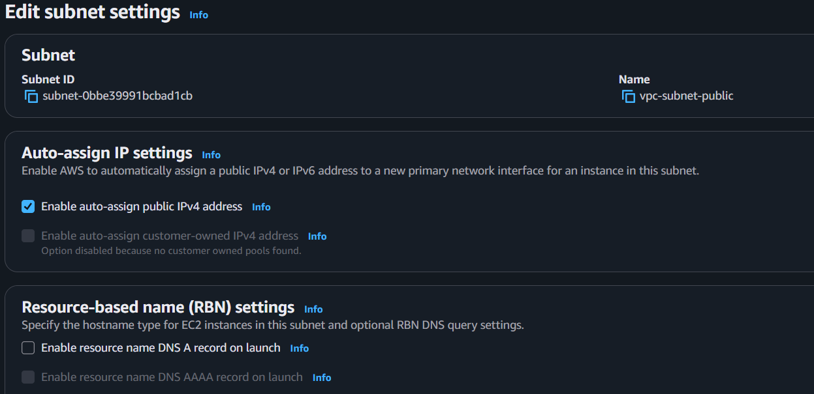

Step 2: Assign the IGW to the Public Subnet (via Route Table)
- Go to Route Tables.
- Create or select the Public Route Table.
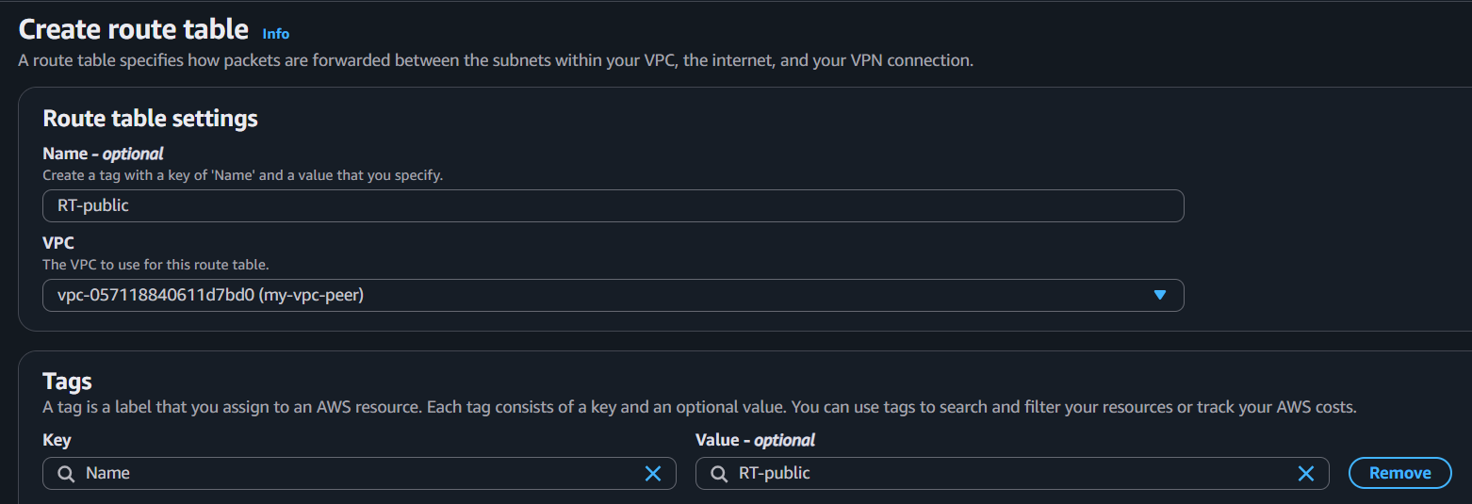
- Click the Routes tab.
- Click Edit routes.
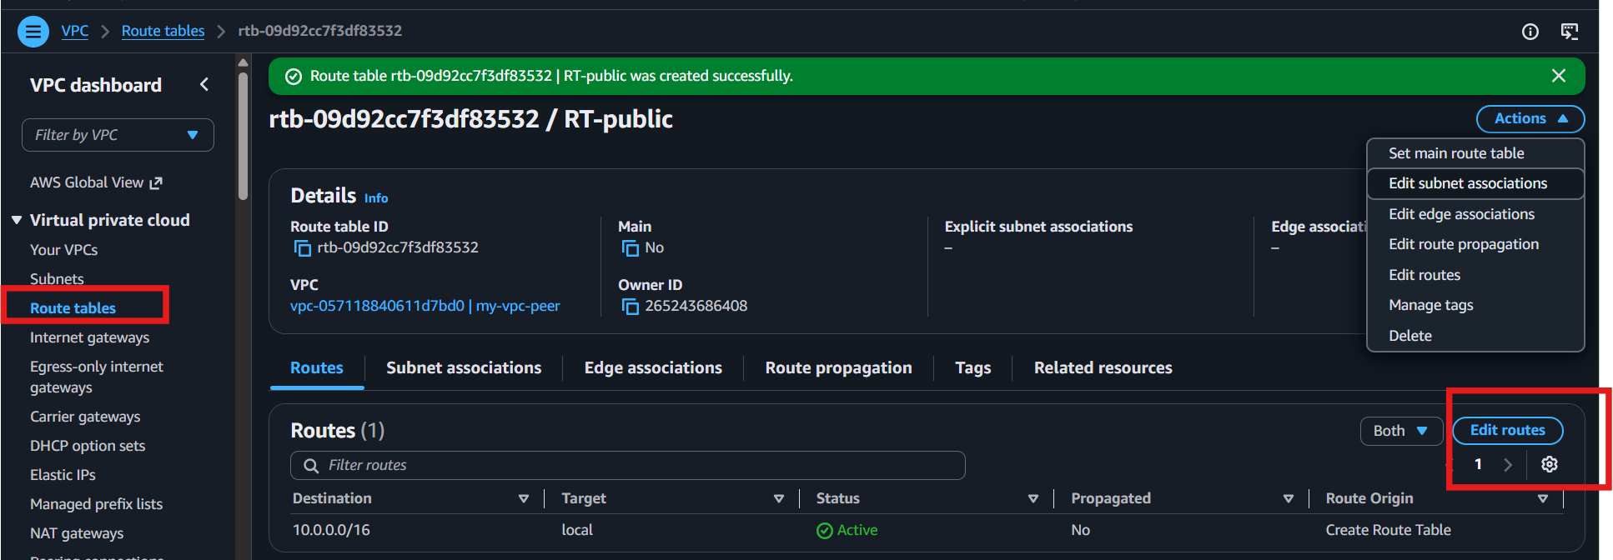
- Add
  - Destination: 0.0.0.0/0
  - Target: Select your Internet Gateway (IGW)

- Save the route.

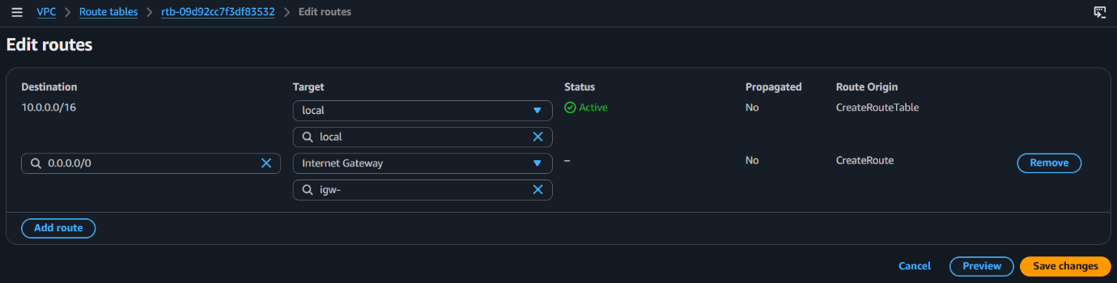
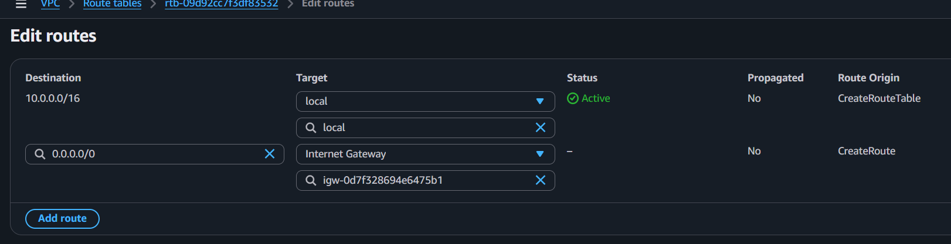
2) Enable VPC peering for cross-region.
3) Enable VPC peering for cross-account (you can collaborate with your friend to do this task).
4) Set up a VPC Transit Gateway.
5) Set up a VPC Endpoint.

